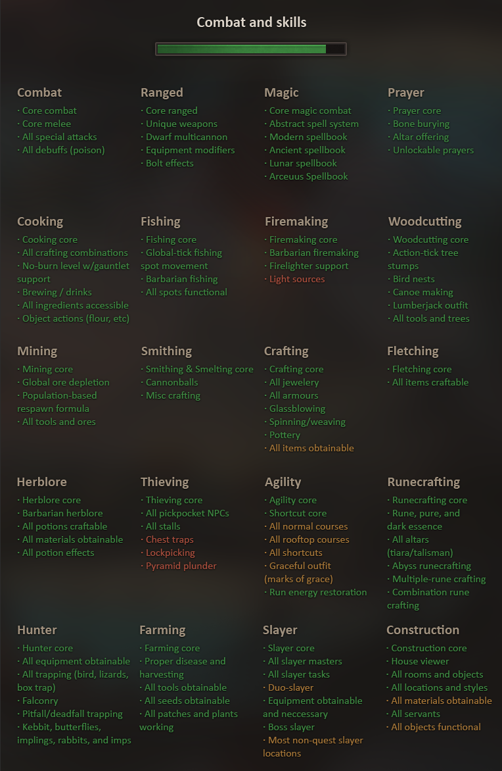

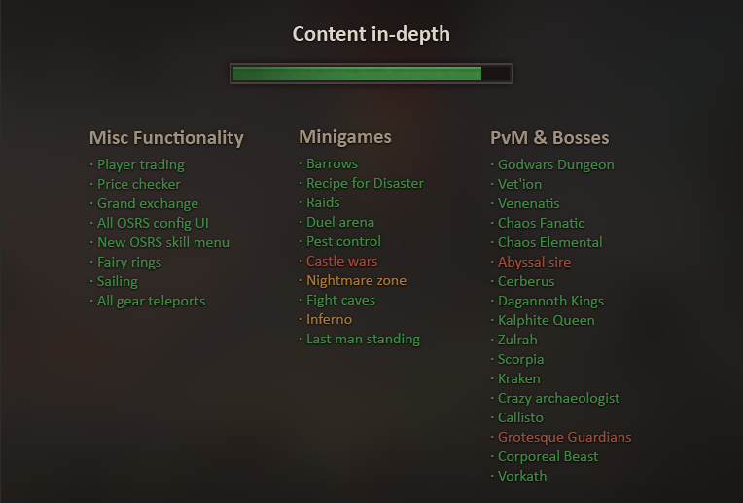

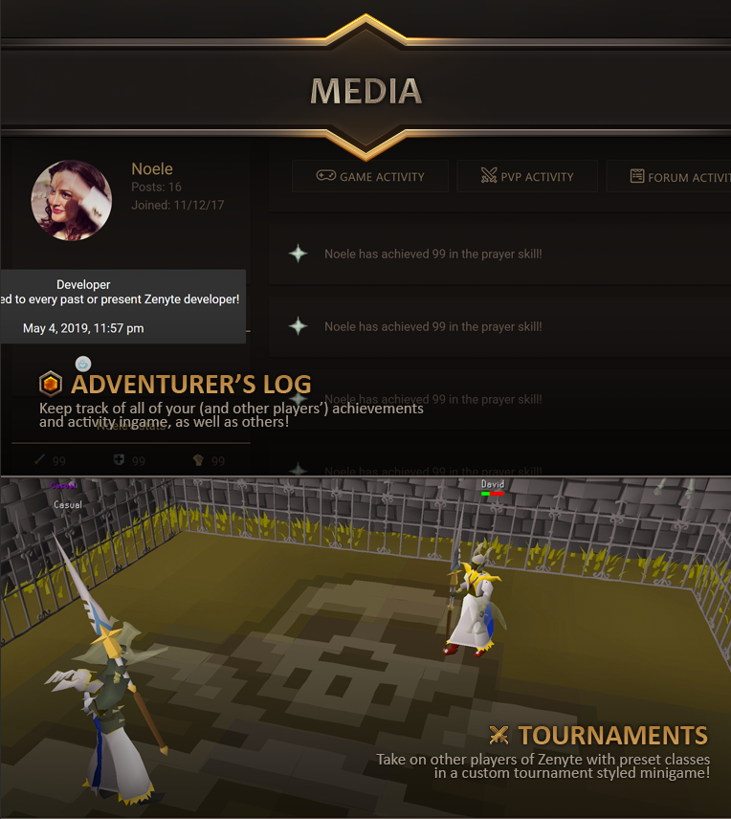

# Combat:

* 1
* 2
* 3
* 4
* 5
* 6
* 7
* 8
* 9
* 10

Attack:

* 1
* 2
* 3

Strength:

* 1
* 2
* 3

Defence:

* 1
* 2
* 3

Ranged:

* 1
* 2
* 3

Magic:

* 1
* 2
* 3

Prayer:

* 1
* 2
* 3

# Skilling:

* 1
* 2
* 3
* 4
* 5
* 6
* 7
* 8
* 9
* 10

RuneCrafting:

* 1
* 2
* 3

Construction:

* 1
* 2
* 3

Agility:

* 1
* 2
* 3

Herblore:

* 1
* 2
* 3

Thieving:

* 1
* 2
* 3

Crafting:

* 1
* 2
* 3

Fletching:

* 1
* 2
* 3

Slayer:

* 1
* 2
* 3

Hunter:

* 1
* 2
* 3

Mining:

* 1
* 2
* 3

Smithing:

* 1
* 2
* 3

Fishing:

* 1
* 2
* 3

Cooking:

* 1
* 2
* 3

Firemaking:

* 1
* 2
* 3

Woodcutting:

* 1
* 2
* 3

Farming:

* 1
* 2
* 3

# Minigames:

* 1
* 2
* 3
* 4
* 5
* 6
* 7
* 8
* 9
* 10

Barrows:

* 1
* 2
* 3

Castle Wars:

* 1
* 2
* 3

Pest Control:

* 1
* 2
* 3

Duel Arena:

* 1
* 2
* 3

Fight Cave:

* 1
* 2
* 3

Fight Pits:

* 1
* 2
* 3

Fun PK:

* 1
* 2
* 3

Clan Wars:

* 1
* 2
* 3

Boss Massacre:

* 1
* 2
* 3

Gambling:

* 1
* 2
* 3

Warriors Guild:

* 1
* 2
* 3

Zombie Apocalypse:

* 1
* 2
* 3

Fishing Trawler:

* 1
* 2
* 3

Inferno:

* 1
* 2
* 3

# Bosses:

* 1
* 2
* 3
* 4
* 5
* 6
* 7
* 8
* 9
* 10

Crazy Archeologist:

* 1
* 2
* 3

Barrelchest:

* 1
* 2
* 3

Venenatis:

* 1
* 2
* 3

Vet’ion:

* 1
* 2
* 3

Callisto:

* 1
* 2
* 3

Chaos Fanatic:

* 1
* 2
* 3

King Black Dragon:

* 1
* 2
* 3

Chaos Elemental:

* 1
* 2
* 3

Scorpia:

* 1
* 2
* 3

Black Knight Titan:

* 1
* 2
* 3

Cerberus:

* 1
* 2
* 3

Godwars:

* 1
* 2
* 3

Corporeal Beast:

* 1
* 2
* 3

Ice Queen:

* 1
* 2
* 3

Giant Mole:

* 1
* 2
* 3

Giant Sea Snake:

* 1
* 2
* 3

Ice Troll King:

* 1
* 2
* 3

Jungle Demon:

* 1
* 2
* 3

Kalphite Queen:

* 1
* 2
* 3

The Untouchable:

* 1
* 2
* 3

Mutant Tarn:

* 1
* 2
* 3

Sea Troll Queen:

* 1
* 2
* 3

Slash Bash:

* 1
* 2
* 3

Kamil:

* 1
* 2
* 3

Dagannoth Kings:

* 1
* 2
* 3

Lizardman Shaman:

* 1
* 2
* 3

Zulrah:

* 1
* 2
* 3

Vorkath:

* 1
* 2
* 3

Alchemical Hydra:

* 1
* 2
* 3

Monkey Gorilla:

* 1
* 2
* 3

Abyssal Sire:

* 1
* 2
* 3

Grotesque Guardians:

* 1
* 2
* 3

Sarachnis:

* 1
* 2
* 3

Thermonuclear smoke devil:

* 1
* 2
* 3

The Nightmare:

* 1
* 2
* 3

Skotizo:

* 1
* 2
* 3

Obor:

* 1
* 2
* 3

TzKal-Zuk:

* 1
* 2
* 3

Great Olm

* 1
* 2
* 3

Galvek:

* 1
* 2
* 3

Bryophyta:

* 1
* 2
* 3

Theatre of Blood:

* Sotetseg
* The Maiden of Sugadinti
* Pestilent Bloat
* Nylocas Vasilias
* Xarpus
* Verzik Vitur

Corrupted Hunllef:

* 1
* 2
* 3

Wintertodt:

* 1
* 2
* 3

Grotesque Guardians:

* 1
* 2
* 3

Penance Queen:

* 1
* 2
* 3

Dad:

* 1
* 2
* 3

Avatars:

* 1
* 2
* 3

Abomination:

* 1
* 2
* 3

Giant Scarab:

* 1
* 2
* 3

Glod:

* 1
* 2
* 3

Me:

* 1
* 2
* 3

General Khazard:

* 1
* 2
* 3

# Content:

* 1
* 2
* 3
* 4
* 5
* 6
* 7
* 8
* 9
* 10

Clan chat:

* 1
* 2
* 3

Player Titles:

* 1
* 2
* 3

Boss Drop Tables:

* 1
* 2
* 3

NPC Kill Tracker:

* 1
* 2
* 3

Collection Log:

* 1
* 2
* 3

Clue Scrolls:

* 1
* 2
* 3

Tasks:

* 1
* 2
* 3

Achievement Diaries:

* 1
* 2
* 3

Quests:

* 1
* 2
* 3

Quest Tab:

* 1
* 2
* 3

Quick Prayers:

* 1
* 2
* 3

Key Bindings:

* 1
* 2
* 3

XP Drop Setup:

* 1
* 2
* 3

Skill Guides:

* 1
* 2
* 3

Command Trivia:

* 1
* 2
* 3

Shooting Star:

* 1
* 2
* 3

Wilderness Boss Spawn:

* 1
* 2
* 3

Emojis:

* 1
* 2
* 3

Bloody Chest / Muddy Chest / Crystal Chest / Brimstone Chest:

* 1
* 2
* 3

Mystery Boxes:

* 1
* 2
* 3

Reward Caskets:

* 1
* 2
* 3

Bank Presets:

* 1
* 2
* 3

Duel Presets:

* 1
* 2
* 3

In-game Highscores:

* 1
* 2
* 3

In-game scoreboards:

* 1
* 2
* 3

2FA:

* 1
* 2
* 3

Staff Management Panel:

* 1
* 2
* 3

Automated Sanction System:

* 1
* 2
* 3

Trading Post:

* 1
* 2
* 3

Items on Death:

* 1
* 2
* 3

Donation Well:

* 1
* 2
* 3

Bonus XP Skills:

* 1
* 2
* 3

Lottery:

* 1
* 2
* 3

Boss Contracts:

* 1
* 2
* 3

Music & Sounds:

* 1
* 2
* 3

Skilling Tasks:

* 1
* 2
* 3

Spell Book Filtering:

* 1
* 2
* 3

New Emotes:

* 1
* 2
* 3

Max Cape:

* 1
* 2
* 3

Doors System:

* 1
* 2
* 3

Wild Resource Area:

* 1
* 2
* 3

Skilling Guilds:

* Cooking Guild
* Fishing Guild
* Mining Guild
* Smithing Guild
* Woodcutting Guild
* Ranged Guild

Donator Zone & Perks:

* 1
* 2
* 3

Updates Notifications:

* 1
* 2
* 3

Password Changer:

* 1
* 2
* 3

Instanced Boss System:

* 1
* 2
* 3

Pet System:

* Pet Insurance
* 2
* 3

Lost Items Retrieval System:

* 1
* 2
* 3

Tutorial System:

* 1
* 2
* 3

Ironman Game Modes:

* Ironman
* Hardcore Ironman
* Ultimate Ironman
* Group Ironman
* Classic Game Mode

Max Cape Customizer:

* 1
* 2
* 3

Yell Customizer:

* 1
* 2
* 3

Item Drop Finder / NPC Drops Interface:

* 1
* 2
* 3

Degrading Items & Repairing:

* 1
* 2
* 3

Items with effects:

* Bonecrusher
* Rune Pouch
* Tome of Fire
* Dragon Hunter Lance
* Dragonfire Shield
* Dragonfire Ward
* Ancient Wyvern Shield
* Ring of Recoil
* Ring of Suffering
* Tormented Bracelet
* Barrows Armour’s
* Torture Amulet
* Serpentine Helmet
* Abyssal’s Tentacle
* Dihn’s Bulwark
* Kodai’s Wand
* Staff of the Dead
* Void Armour
* Justiciar Armour
* Sled
* Easter Egg Basket
* Pantaloons
* Sleeping Cap
* A powered wig
* Bone sack
* Ornament Kits
* Skilling Tomes
* Chicken Set
* Wizard mind bomb
* Aggressivity Potion
* Snow balls
* Potato
* Beer
* Silver Light / Dark Light / Arclight
* Skillcape Perks
* Rogue Set
* Dodgy Necklace
* Bandits Brew
* Recolored Whips Effects
* Mirror Shield / Bag of Salt / Waterskins / Rock Hammer / Face mask / Ear muffs / Nose peg / Slayer’s staff / Slayer’s helmet / Fishing Explosive / Ice Cooler / Slayer’s gloves / Unlit bug lantern / Insulated boots / Fungicide Spray / Slayer Bell / Leaf bladed spear
* Slayer Ring
* Amulet of Damned
* Slayer’s helmet
* Ava’s
* Godwars items (Zamorak / Saradomin / Guthix)
* Dwarven Rock Cake
* Chicken Set
* Fairy Ring+
* Slayer Mask
* Cooking gauntlets
* Inferno Items
* Double XP Ring
* Prospector Set
* Builders Set
* Witchdoctor Set
* Looting Bag
* Gem Bag
* Mining Bag
* Thieving Bag
* Scythe of Vitur
* Twisted Bow
* Salve amulet
* Rod of ivandis
* Dragon Warhammer
* Trident of Seas / trident of Swamp
* Spirit shields
* Lumberjack set
* Angler set
* Essence pouches